Active Belfast Projects 2015/16

Summary
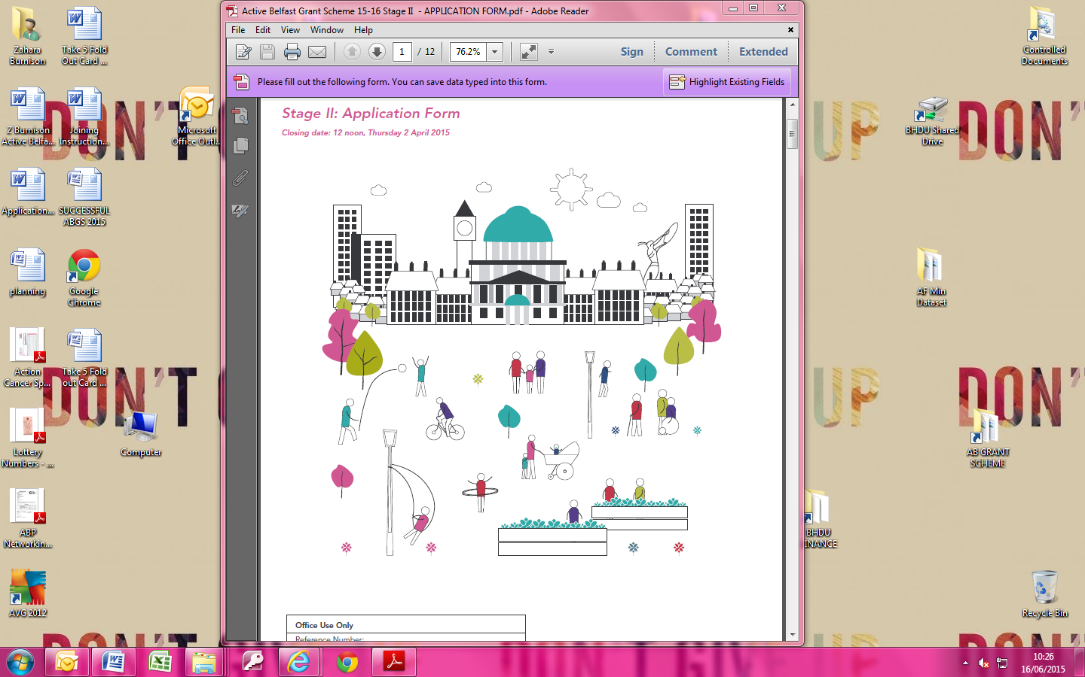
‘Working together to inspire more people to be more active more often’.

Active Belfast Projects 2015/16
Synopses

Grants Cycling

Priority 1
Cedar Foundation: On Yer Bike – Kidz Start
The On Yer Bike – Kidz Start project will provide young people with disabilities aged between 6 and 18 an opportunity to increase their physical activity levels through cycling, while learning new skills and improving their health.

The project will support young people to develop cycling efficiency skills through accredited training and also facilitate a peer mentoring and support programme for adults with disabilities. This work will be support by Tri-Cycle.

Action Cancer will also support the programme, providing health and wellbeing sessions to the young people, increasing their knowledge and awareness of the benefits of physical activity.

Priority 2
Autism Initiatives: Cycling Skills
The Cycling Skills project will develop the cycling ability and confidence of young people aged 8 to 16 years, with Autism Spectrum Condition (ASC), enabling them to cycle independently in an outdoor environment.

The project will focus on developing key skills including cornering, pedalling, braking and avoiding obstacles and will be delivered on the Connswater Community Greenway in partnership with the Connswater Community Greenway Trust. Family cycling sessions will also be held along the Greenway.

The project will also offer bike maintenance sessions which will be held at the Skainos Centre.

Nutrition: Increased awareness of nutrition amongst participants (8-16 years) and their families.

Colin Glen Trust: Trail Blazers
Trail Blazers is a group cycling project for hard to reach teenagers from the Suffolk, Lenadoon, Poleglass, Twinbrook and Colin areas of Belfast. The project aims to get teenagers more active by introducing them to various aspects of cycling including on road, off road and cycle networks.

Trail Blazers will include sessions on cycle skills, bike maintenance, healthy eating, first aid and rights and responsibilities.

Colin Youth Empowerment Programme and Kids Together will support Colin Glen Trust in recruiting young people, ensuring an inclusive opportunity for all.

Clubs for Young People: Cycle Wise
The Cycle Wise project will work with young people from youth clubs across the city, promoting positive mental health through cycling.

The young people will receive skills development training in road cycling, first aid and bike maintenance, as well as messages on positive mental health and resilience. Once qualified the young people will bring their newly acquired knowledge back to their youth club and local community and deliver a cycling project for younger members of the club.

The project will be supported by Lighthouse and Real Cycles.

Nutrition: Young people will take part in a health challenge over 6 weeks promoting healthier lifestyle choices including better eating habits.

Cycling Ireland: Bike for life
The Bike for Life project will create a network of Ride Leaders, who will be trained to inspire and motivate people to be more active through recreational and leisure cycling, focusing on increasing cycling levels within women.

The Bike for Life Leaders will be qualified to deliver lead rides for groups of beginners and intermediate level cyclists, with training included on preparing for a ride, riding safely, bike handling skills and bike maintenance.

The project will be supported by Cycling Ulster and the South Belfast Partnership.

Carlisle House Substance Misuse Centre: Try Cycle
The Try Cycle project will provide opportunities for past and present services users of Carlisle House and Gray’s Court, to increase their confidence and physical activity.

The project will develop through the training of volunteer services users, who will be trained within Belfast Metropolitan College, to deliver a series of indoor cycling sessions aimed to improve the confidence and fitness levels of participants.

Following this a series of outdoor cycling sessions will be delivered by Sustrans, leading to the establishment of a cycling club.

Nutrition: The Cook it and Food Values programme will be delivered by trained staff to service users to help promote good nutrition and food hygiene practices as well as enhancing cooking and budgeting skills.

Grants Neighbourhoods

Priority 1
Greater Shankill Partnership: ‘Strictly Active’
The ‘Strictly Active’ project will be making positive use of public space through a new initiative ‘Distance Dancing’ and will engage with older people/people living with dementia in dance and through this to encourage and enable physical activity and positive mental health.

The project will support the city as a whole but seeks to locate key activity at a grass-roots community level, by establishing a first dancer in residence scheme based in 4 settings in each quarter of the city, Hosting community based showcase events drawing on other participants in an end of project central showcase and celebration event;

The project will focus on building legacy by up skilling staff, carers and volunteers; providing toolkits and building skills.

Priority 2
St Malachy’s Youth Centre: Multi Sports & Coach Education Programme
The Multi Sports & Coach Education Programme will increase the number and variety of activities available to young people within St Malachy's Youth Centre and to engage with other groups to raise opportunities in sport and physical activity across the city.

St Malachy's will do this by providing access to;

- Zumba/Dance sessions, exercise
- Fitness training (along with accredited qualifications for sustainability)
- Basketball

St Malachy’s will work in partnership with numerous primary schools and other Youth Centres.

East Belfast Sure Start: SHINE TOO
The SHINE TOO project target families during pregnancy and with children up to the age of 3 who are unlikely to participate in physical activity or to engender this ethos in their children. This early intervention programme will enrich bonding and attachment, enabling families to enjoy quality time in physical activities together for mutual benefit, redressing health inequalities.

It will support the neighbourhood by encouraging active participation in fun, family friendly activities that are accessible and free.

East Belfast Sure Start will work in partnership with Short Strand Community Forum and Home Start.

Nutrition: To provide information to parents regarding a healthy diet to help address obesity. This will be done via workshops on a balanced diet for adults as well as through information provided on weaning to parents. In addition the Cook it! programme will help increase knowledge of a healthy diet, enhance cooking skills, food preparation and give participants an opportunity to try new foods.

Disability Sport NI (DSNI): Training for Inclusion
Training for Inclusion will develop an infrastructure of volunteers with the skills and knowledge to deliver physical activity sessions in their local areas, enabling people with disabilities (pwd) to lead healthy, active lifestyles in their own neighbourhoods.

Their suite of training courses will be delivered across the city on a geographical basis and will be offered to individuals in community and voluntary organisations working in North, South, East and West Belfast.

Play Board NI: Belfast CAN Play
The Belfast Can Play project will increase children’s level of physical activity through play and make more effective use of community spaces and places for physical activity.

The project will do this by delivering a play based physical activity training programme to community volunteers providing the skills necessary to sustain long-term, ongoing delivery of children's physical play sessions in each area across the city and will provide ongoing mentor support to each partner.

The project will support their neighbourhoods with partners delivering 4 play days within their community, the final taking place on national Play Day (5/8/15).

The project will establish a sustainable play volunteer group in each area.

Inner South Neighbourhood Renewal Partnership: Inner South health initiative
The project aims to increase the physical activity levels of up to 400 individuals targeting 3 key areas, Multi-Cultural, Older & Active and Women. It will achieve this by delivering, a summer sports scheme for 5-15 year olds, a 12 week fitness and dance activity programme for the 50+ and a 24 week scheme including Pilates, Zumba and Aerobics targeting women.

The project will support people in the neighbourhood and facilitate greater connections between people, places and organisations by targeting individuals that are traditionally underrepresented (i.e. minority ethnic communities including Somali, Roma, Ivorian).

The project will be supported by a range of partners to name a few: Lower Ormeau Residents Action Group, Belfast community Sports Development Network, Market’s Development Association, Donegal Pass Community Forum, Droichead Cultural Centre,

Nutrition: The project will increase awareness and knowledge of good nutrition, preparing healthy food on a budget and cooking skills by encouraging participation in Cook it! programmes. A group weight management programme will also be provided to help support those who are keen to lose weight by combining a healthy diet with physical activity and behaviour change techniques (Weigh to Health programme).

Greater Village Regeneration Trust (GVRT): Community Challenge
The Community Challenge project will deliver a community engagement project within South West area of Belfast. This will be achieved by establishing a Community Challenge between two localised communities within the area - Sandy Row and Village Areas targeting various demographics

- Biggest Weight loser for women
  - Strongest Man for men
  - Senior Games league
  - Youth Team Challenge
  - Fittest Primary School

This project will improve opportunities for participants and to allow the local community to take ownership of their social spaces and use the space for physical activity.

The project will cumulate with a festival event in March 2016 to showcase individual activity sessions and to celebrate the success of the programme.

The project is working in partnership GVRT, Belfast South Community Resources and Belfast Community Sports Development Network.

Grants Nutrition Only

St Joseph’s Primary school
A series of monthly cookery classes (over 6 months) with parents and children will teach participants how to make seasonal soup. This aims to increase intake of vegetables by allowing participants to

- taste a range of vegetables
- learn how to cook soup together

Shaftesbury Bowling Club
This initiative will deliver eatwell bingo events promoting healthy eating messages for older people. Participants will be given fruit and vegetable samples to try and some to take home to help ``increase their intake in a very practical way.

New Lodge Duncairn Community Health Partnership
The Food Values programme will be delivered to groups to help increase knowledge and skills around budgeting for healthier meals.

Gleann Amateur Boxing Club
This initiative will work to help improve eating habits of girls attending the boxing club. Parents and their daughters will be involved so that family eating habits can be positively influenced.

Annadale Haywood Residents Association
Positive nutrition choices and skills in cooking healthy meals on a budget will be promoted in this project through the delivery of a nutrition/ cooking programme (Cook it!). A wider appreciation of food from a variety of cultures will be promoted through the Taste of the World programme.

Hannahstown Community Association
This initiative will improve awareness of a healthy diet and cooking on a budget through the delivery of the Cook it! programme. Participants will have an opportunity to taste and eat healthier options as part of the programme.

Healthwise- Physical Activity Referral Programme

Belfast City Council
The Healthwise- Physical Activity Referral Programme aims to get inactive people who suffer from a range of health conditions more active. Belfast City Council in partnership with Active Belfast deliver physical activity opportunities to over 2000 people per year across Belfast, playing an important role in improving people’s health and well-being. Belfast City Council also delivers phase IV cardiac rehabilitation programmes to over 200 people per year who have had a cardiac event.

Lisburn and Castlereagh City Council
Lisburn and Castlereagh City Council in partnership with Active Belfast deliver a range of physical activity opportunities for people taking part in the Healthwise programme with over 300 people per year taking part in the Castlereagh area. They also deliver phase IV cardiac rehabilitation programmes for people who have had a cardiac event.

The Heart Project at Maureen Sheehan Centre
The Heart project in partnership with Active Belfast is delivering a range of physical activity opportunities for people across West and North Belfast. The project also delivers a range of rehabilitation programmes for clients to help better manage long term conditions including Cardiac, Cancer and older people who have had a fall.

Lower Ormeau Residents Action Group at Shaftesbury Recreation Centre
Lower Ormeau Residents Action Group in partnership with Active Belfast delivers physical activity opportunities to people across South and East Belfast. Over 250 people take part in the programme each year and the project now delivers programmes to people with COPD to help them better manage their condition.

JogBelfast Programme

The aim of the JogBelfast programme is to encourage people who are inactive and have not run before to get active by taking up walking, jogging or running. The programme is delivered in local communities across Belfast and open to people of all ages and abilities. Active Belfast and partners have to date had over 2,000 people registered for the programme.

